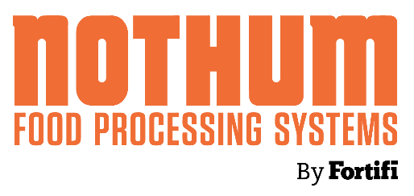 | NEWS RELEASE
MEDIA CONTACTS:
Nothum Food Processing Systems
Kierstin Holland
Marketing Manager
+1 417.831.2826
kierstin.holland@nothum.com
or
dgs Marketing Engineers®
Vanessa Stiles
Chief Strategy Officer
+1 317.813.2237
stiles@dgsmarketing.com

Nothum Highlights Predust, Batter, Breading and Frying Equipment at IPPE 2026
Fortifi global brands share innovations for the future of further processing
SPRINGFIELD, Missouri, November 25, 2025 – Nothum Food Processing Systems, a Fortifi Food Processing Solutions company, will present predust, batter, breading and frying solutions at the International Production & Processing Expo from January 27-29, 2026, in Atlanta, Ga. In Blue Hall C, Booth C31129, Nothum will join other companies within the Fortifi Food Processing Solutions unified platform of leading global brands to showcase technological innovations for food processing.
At IPPE, visitors will experience the SuperFlex Breading Machine, featuring drum, flatbed, tripleflip and handtoss application modes – ideal for applying various coatings such as rubs, fine flours, and coarse crumbs.
Nothum will showcase its latest advancement in batter and tempura application technology with the BatterKing. This fully integrated system efficiently mixes, chills and applies batter or tempura with an automatically controlled viscosity.
Also in action at IPPE, the VersaCoat Flatbed Breading Machine showcases a low-charge breading system. The VersaCoat is designed to handle multiple coating types – from fine flours to coarse crumbs – without compromising the coating's integrity.
Nothum also will present the ProTherm Continuous Fryer, which demonstrates multiple efficiencies while utilizing 33% less frying oil for consistent product quality. Featured with the fryer is Nothum's EzFlow Oil Filter, which safely removes sediments and reduces free-fatty acids through a low-pressure system.
Lastly, Nothum will highlight the HydroFilter Dust Collector, which captures and removes flours and rubs from the air for a cleaner, more breathable work environment.
In addition to Nothum, representatives from Bettcher, Frontmatec, MHM Automation, LIMA, Kais, Cantrell-Gainco, Greenline and Fortifi partner Völur will present transformative food processing and automation solutions during the world's largest annual food industry event for the poultry and egg, meat and animal food industries.
About Nothum Food Processing Solutions
Nothum Food Processing Solutions creates industry-leading high-tech predust, batter, breading and frying equipment that reduces downtime while it boosts production efficiency and savings. Tailored designs meet unique customer needs with elite performance. Nothum serves the poultry, seafood, appetizer, alternative-protein and snack food industries with products that maximize flavor and minimize food waste. Located in Springfield, Mo., and the Netherlands, Nothum is part of Fortifi Food Processing Solutions. For more information, please visit www.nothum.com.
About Fortifi Food Processing Solutions
Headquartered in The Woodlands, Texas and operating worldwide, Fortifi is a leading platform of automated food processing equipment and automation solutions. Fortifi serves customers worldwide through its global manufacturing and service footprint, and drives improvements in yield, productivity, food quality, and worker safety for many of the world’s largest food producers. Fortifi’s growing portfolio includes Bettcher Industries, Frontmatec, MHM Automation, Nothum Food Processing Systems, REICH Thermoprozesstechnik GmbH, LIMA (Les Innovations Mecaniques Alimentaires) and Kais. For more information, please visit: www.FortifiFoodSolutions.com.
###

