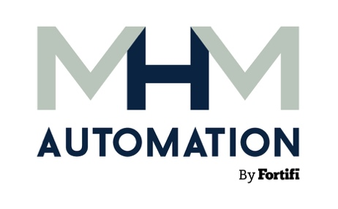 | NEWS RELEASE
MEDIA CONTACTS:
MHM Automation
Charlotte Neilson
Senior Marketing Consultant
+64 21 775 298
c.neilson@mhmautomation.com
or
dgs Marketing Engineers®
Vanessa Stiles
Chief Strategy Officer
+1 317.813.2237
stiles@dgsmarketing.com

MHM Automation Demonstrates RPC Erector at IPPE 2026
Reduces manual handling during production of meat, poultry and other perishables

THE WOODLANDS, Texas, November 20, 2025 – At the International Production & Processing Expo (IPPE) from January 27-29, 2026, in Atlanta, Ga., MHM Automation will showcase its RPC Erector, designed to simplify production-line palletizing of meat, poultry and other perishable goods. As part of Fortifi Food Processing Solutions, MHM representatives will be on hand in Blue Hall C, Booth C31129, to present solutions that optimize meat production applications.
MHM Automation designs and supplies innovative product handling, chilling and freezing solutions that transform efficiency, sustainability, safety and quality. As part of that product line, the RPC Erector automatically de-stacks and erects full pallets of Tosca meat reusable plastic containers (RPCs) for immediate production-line use, which reduces manual handling for improved workplace safety, reduced labor costs and optimized efficiency in space-constrained environments.
The machine delivers 12 erected crates per minute with sustained operation. Up to 10 minutes' notice of reload time ensures a reliable supply and uninterrupted performance. Built-in safety provisions include light curtains to protect operators during loading and an integrated light bar for real-time status visibility. The available model suits most line speeds and can discharge crates long-edge or short-edge to meet line requirements. Additionally, it is able to erect different-sized Tosca meat RPCs without stopping or changing the machine setup.
The compact design of the RPC Erector fits seamlessly alongside existing processing lines in a footprint no larger than a manual workstation with a pallet of assembled crates (8' x 5'). Its stainless steel chassis and robust mechanical assemblies deliver reliable machining with easy operation and maintenance. Autonomous Mobile Robot (AMR) compatibility for flat pack loading and an intuitive user interface automate the erection process without requiring experienced operators.
In addition to MHM Automation, representatives from other Fortifi companies – Bettcher, Frontmatec, LIMA, Nothum, REICH, Kais, Cantrell-Gainco and Greenline – and partner Völur will be on hand at IPPE 2026 to share transformative technologies.
About MHM Automation
MHM Automation designs and supplies innovative, world-leading processing and handling equipment to support the global food processing sector. MHM began in Christchurch, New Zealand, in 1884 and has evolved into a technology and automation-led business focused on continuous improvement and innovation. The company’s growth is driven by innovation, perseverance, and the integration of legacy brands that enhance its automation expertise. MHM Automation is a proud part of Fortifi Food Processing Solutions. For more information, please visit mhmautomation.com.
About Fortifi Food Processing Solutions
Headquartered in The Woodlands, Texas and operating worldwide, Fortifi is a leading food processing automation solutions platform. Fortifi serves customers through its global manufacturing and service footprint, and drives improvements in food quality and yield, labor productivity, and worker safety for many of the world’s largest food producers. Fortifi’s growing portfolio includes Bettcher, Frontmatec, MHM Automation, Nothum, REICH, Kais Software, LIMA, Wyma, Area 52, Cantrell-Gainco, Greenline and BANSS. For more information, please visit: www.FortifiFoodSolutions.com.
###

