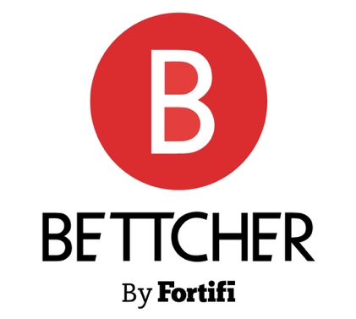 | NEWS RELEASE
MEDIA CONTACTS:
Bettcher Industries
Connor Guyton
Marketing Manager
+1 662.418.2965
ConnorGuyton@bettcher.com
or
dgs Marketing Engineers®
Vanessa Stiles
Chief Strategy Officer
+1 317.813.2237
stiles@dgsmarketing.com

Bettcher Industries Showcases Meat Processing Tools at IPPE 2026
Bettcher will feature trimmers, derinding and membrane skinning technologies

BIRMINGHAM, Ohio, November 7, 2025 – Bettcher Industries will demonstrate premium-quality precision tools for meat processing at the International Production & Processing Expo from January 27-29, 2026, in Atlanta, Ga. As part of Fortifi Food Processing Solutions, Bettcher representatives will be on hand in Blue Hall C, Booth C31129, to present solutions that enhance meat production applications.
At IPPE, attendees will learn more about Bettcher's rebuild kits and service contracts to update equipment and schedule preventive maintenance. Bettcher will demonstrate the robust, versatile Whizard® Versa™ Trimmer, with innovations including a TWIST-N-GO head and two speed options to swap between applications easily.
Bettcher will also demonstrate its Quantum Flex and Flex+® Trimmers, which improve performance and durability and are compatible with any Bettcher motor system, including Quantum, UltraDrive and UN-84. Design simplicity results in easier maintenance and increased efficiency, while lighter weight improves operator ergonomics.
Bettcher will feature Grasselli derinding and membrane skinning technology, including the MS600P membrane skinner, which provides a precise high-yield solution with efficient sanitation in a single or optional dual-blade version. For complete operator safety, Grasselli's CLO safety system protects operators' hands. The fully automatic NAB520 guarantees accurate precision even with delicate pork cuts. Its infeed belt adjusts relative to the blade and toothroll for optimal operations.
In addition to Bettcher, representatives from other Fortifi companies – Frontmatec, MHM Automation, LIMA, Nothum, REICH, Kais, Cantrell-Gainco and Greenline – and partner Völur will be on hand at IPPE 2026 to share transformative technologies.
About Bettcher Industries
Since 1944, Bettcher has delivered innovative solutions that empower butchers and meatpackers with increased yield and productivity. Bettcher understands and solves worldwide customer challenges through tools and solutions that enable customers to achieve optimal results from each trimming, skinning and breading application without sacrificing quality, yield, and safety. Headquartered in Birmingham, Ohio, Bettcher is part of Fortifi Food Processing Solutions. For more information, please visit bettcher.com.
About Fortifi Food Processing Solutions
Headquartered in The Woodlands, Texas and operating worldwide, Fortifi is a leading food processing automation solutions platform. Fortifi serves customers through its global manufacturing and service footprint, and drives improvements in food quality and yield, labor productivity, and worker safety for many of the world’s largest food producers. Fortifi’s growing portfolio includes Bettcher, Frontmatec, MHM Automation, Nothum, REICH, Kais Software, LIMA, Wyma, Area 52, Cantrell-Gainco, Greenline and BANSS. For more information, please visit: www.FortifiFoodSolutions.com.
###

